Braden M Wendt

CS 200

Project 9: Maze pt 1

# Overview:

In this project we are to build out the necessary functions for building a maze. They consist of rand, XYToIndex, IsInBounds, and PrintGrid. We are given skeleton C code which replicates what we are going to build. For this project we do not need to have a complete maze, but only have a wall of “#” characters. The other functions are like things we have done before, they provide certain functionality for the next project.

# Results:

I started with the rand function in which I used a similar method to a previous project. The seed and RGEN are loaded in, and they are both used in the equation. This function saves the random number to the stack.

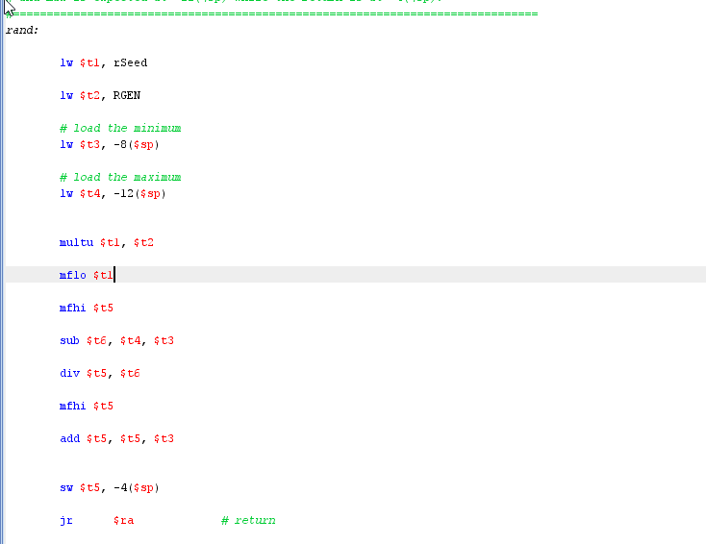

The XYToIndex function is simpler, only replicating a formula and saving the result to memory as well. The equation is “y * GRID_WIDTH + x;”.

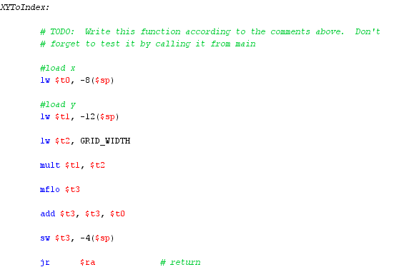

The next function is the IsInBounds function which checks if x and y are in certain bounds and returns the value true or false.

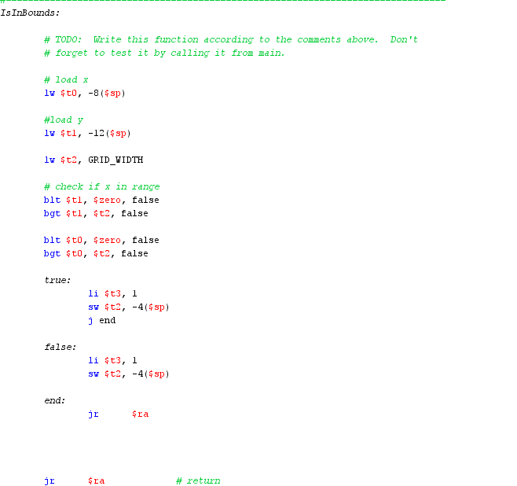

The last function is PrintGrid which prints the given .space variable as a string and gives the wall of “#” characters that is being looked for.

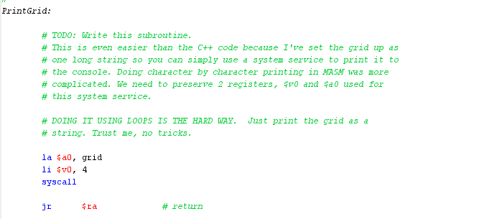

# Sample Output:

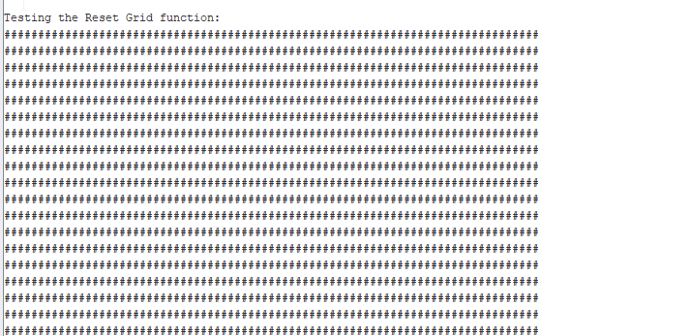

# Conclusion:

This project is a build up to the main maze project which is project 10. In this project I did not have much difficulty building these functions because I have just spent the past couple of days studying MIPS Assembly in preparation for the exam. I found that I was able to build out of all of the functions without too much problem. The thing that kind of stumped me was the PrintGrid function and how a .space variable was supposed to be printed as a string. I found it somewhat confusing how it worked but realized that the number in front represented how much space it held.

All in all, I do not have a lot to say about this project, and it was definitely nice to have a project feel more doable. I felt like I had more confidence in myself this time while coding in MIPS Assembly, and I think that I more capable of building complex programs. In the meantime, I will prepare for Project 10 and learn the concepts that will end up being applied to making a random maze.